Ideation phase
Laptop Request catalog item
Date
Team ID | NM2025TMID07125
Project Name | Laptop Request catalog item
Maximum Marks

Laptop Request catalog items :
The Laptop Request catalog item in ServiceNow enables employees to request a new, replacement, or upgraded laptop for business use. It ensures all users receive secure, pre-configured devices that meet company standards. Requests can be made for new hires, hardware refreshes, or replacements for damaged or lost laptops.
This service is available to full-time employees, contractors (with approval), and interns with limited options. Each request goes through manager and IT Asset Management approval to ensure compliance and stock availability.
Employees can choose from Standard, Performance, or Executive models based on job role and business need. Optional accessories such as docking stations, monitors, and peripherals can be added.
The request form includes fields for justification, manager details, and delivery location. Once approved, IT prepares and configures the device, then arranges delivery or pickup.
Fulfillment time is typically 3–5 days for standard laptops and 7–10 days for higher-end models. Employees must return any replaced devices within five days of receiving the new one.
For issues or repairs, users can contact the IT Service Desk or raise a ticket under Hardware Support. This catalog item streamlines laptop provisioning, ensures policy compliance, and supports a consistent, efficient employee experience.

References :
Here are reference links for creating and managing catalog items in ServiceNow:
- https://www.servicenow.com/docs/en-US/bundle/xanadu-servicenow-platform/page/product/service-catalog-management/task/create-item-cat-builder.html

Step -1 Team gathering, collaboration and select the problem statement
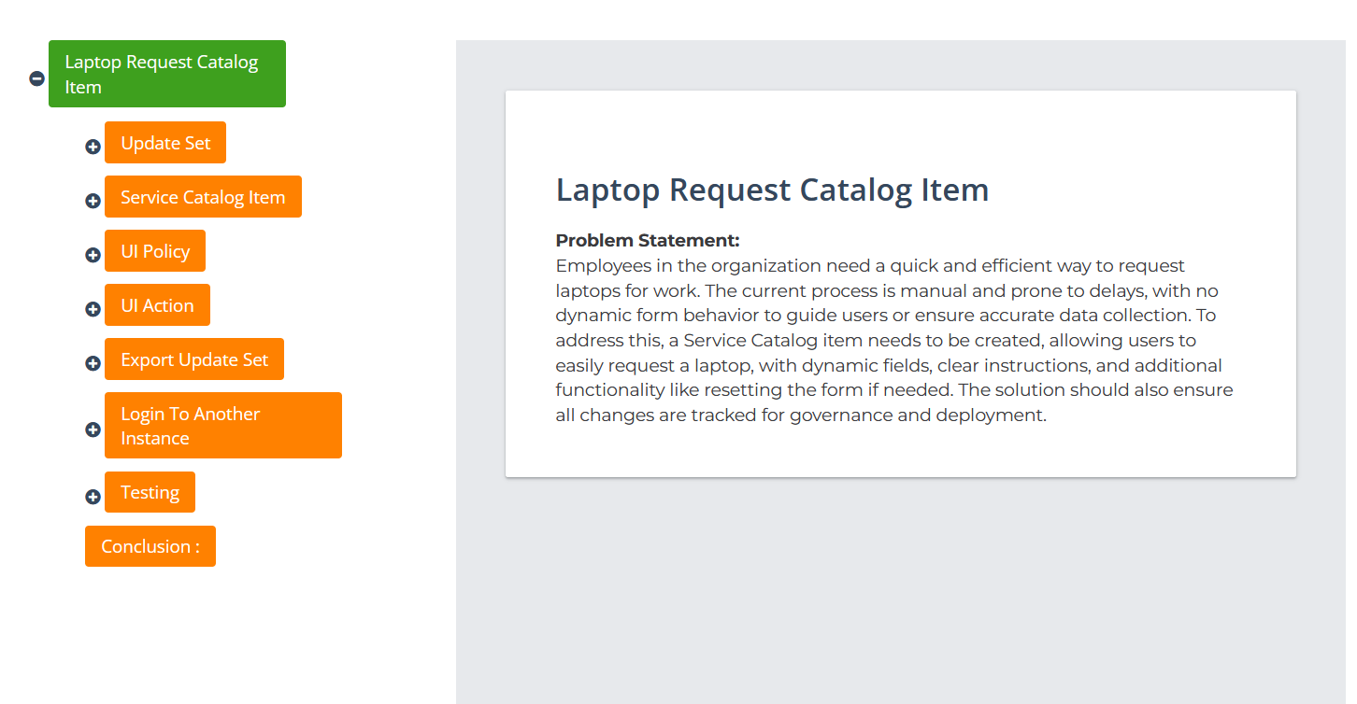

Step -2 Service catalog items and category of Laptop Request

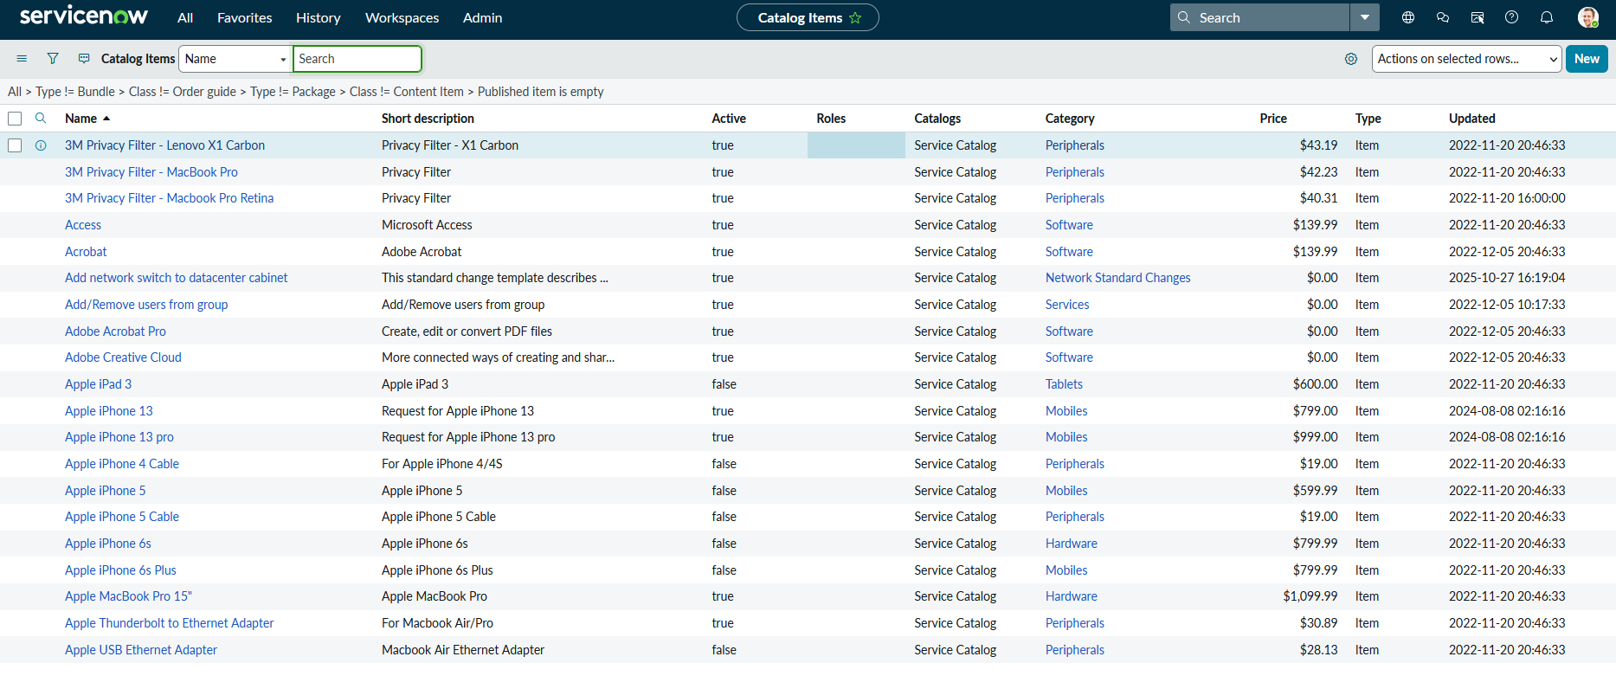

Step -3 update catalog sets and search in Laptop Request

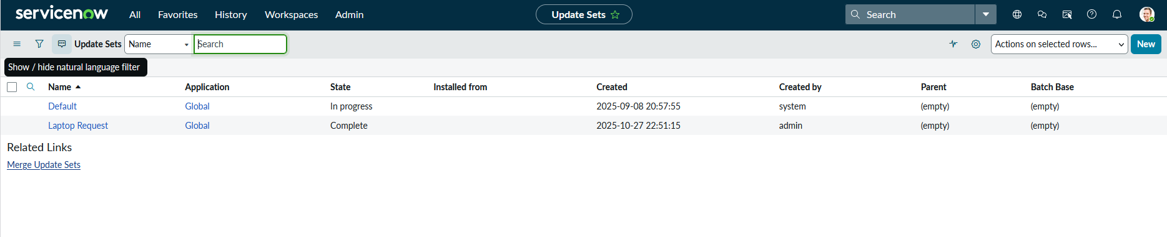
Step -4 Laptop Request in UI actions

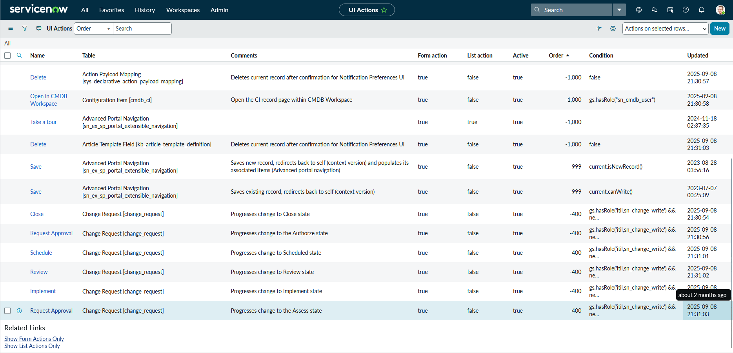

Step -5 Idea prioritization and final output

